Schizophrenia Society of Canada  (SSC) since 1979  Serving more than just  Schizophrenia!  Vision  To improve the quality of life and to promote a dignified, non-discriminatory quality of life for those affected by mental illness and addiction; using education and support programs.  The Schizophrenia Society of New Brunswick- (SSNB) is a non-profit community-based organization that was first developed in 1986 as a family support group under the name “Family and Friends” and joined SSC in 1994.  SSNB was incorporated in 1993 |  | SSNB PROGRAMS & SERVICES  Care-Giver Support Group is an informal on-going support group available to the families and primary caregivers of those affected with a long-term mental illness or addiction.  Strengthening Families Together is a 6-10 session family education course for families/caregivers and friends of those coping with mental illness/addiction.  J. Dean McAllister Memorial Bursary is awarded annually to a high school graduate pursuing a career in one of the selected social sciences. Applications must be received prior to May 25.  ACHIEVES literacy and Numeracy is an educational program specifically tailored for persons who have experienced a mental health/addiction disorder and are now coping well enough to try a new challenge through learning skills or upgrading skills lost through trauma.  ACHIEVES Employment Skills is a valuable tool in teaching employment skills to those recovering from a mental illness/addiction. Our mission is to provide support and training in the participants journey to gaining meaningful employment and achieving self-sufficiency.  Your Recovery Journey is a valuable resource for those affected by metal illness who are looking for  helpful tools to assist them in their recovery. Recovery is a practical concept it works in real life, with real people… (Michael Kirby Chair Mental Health Commission of Canada) | Bipolar  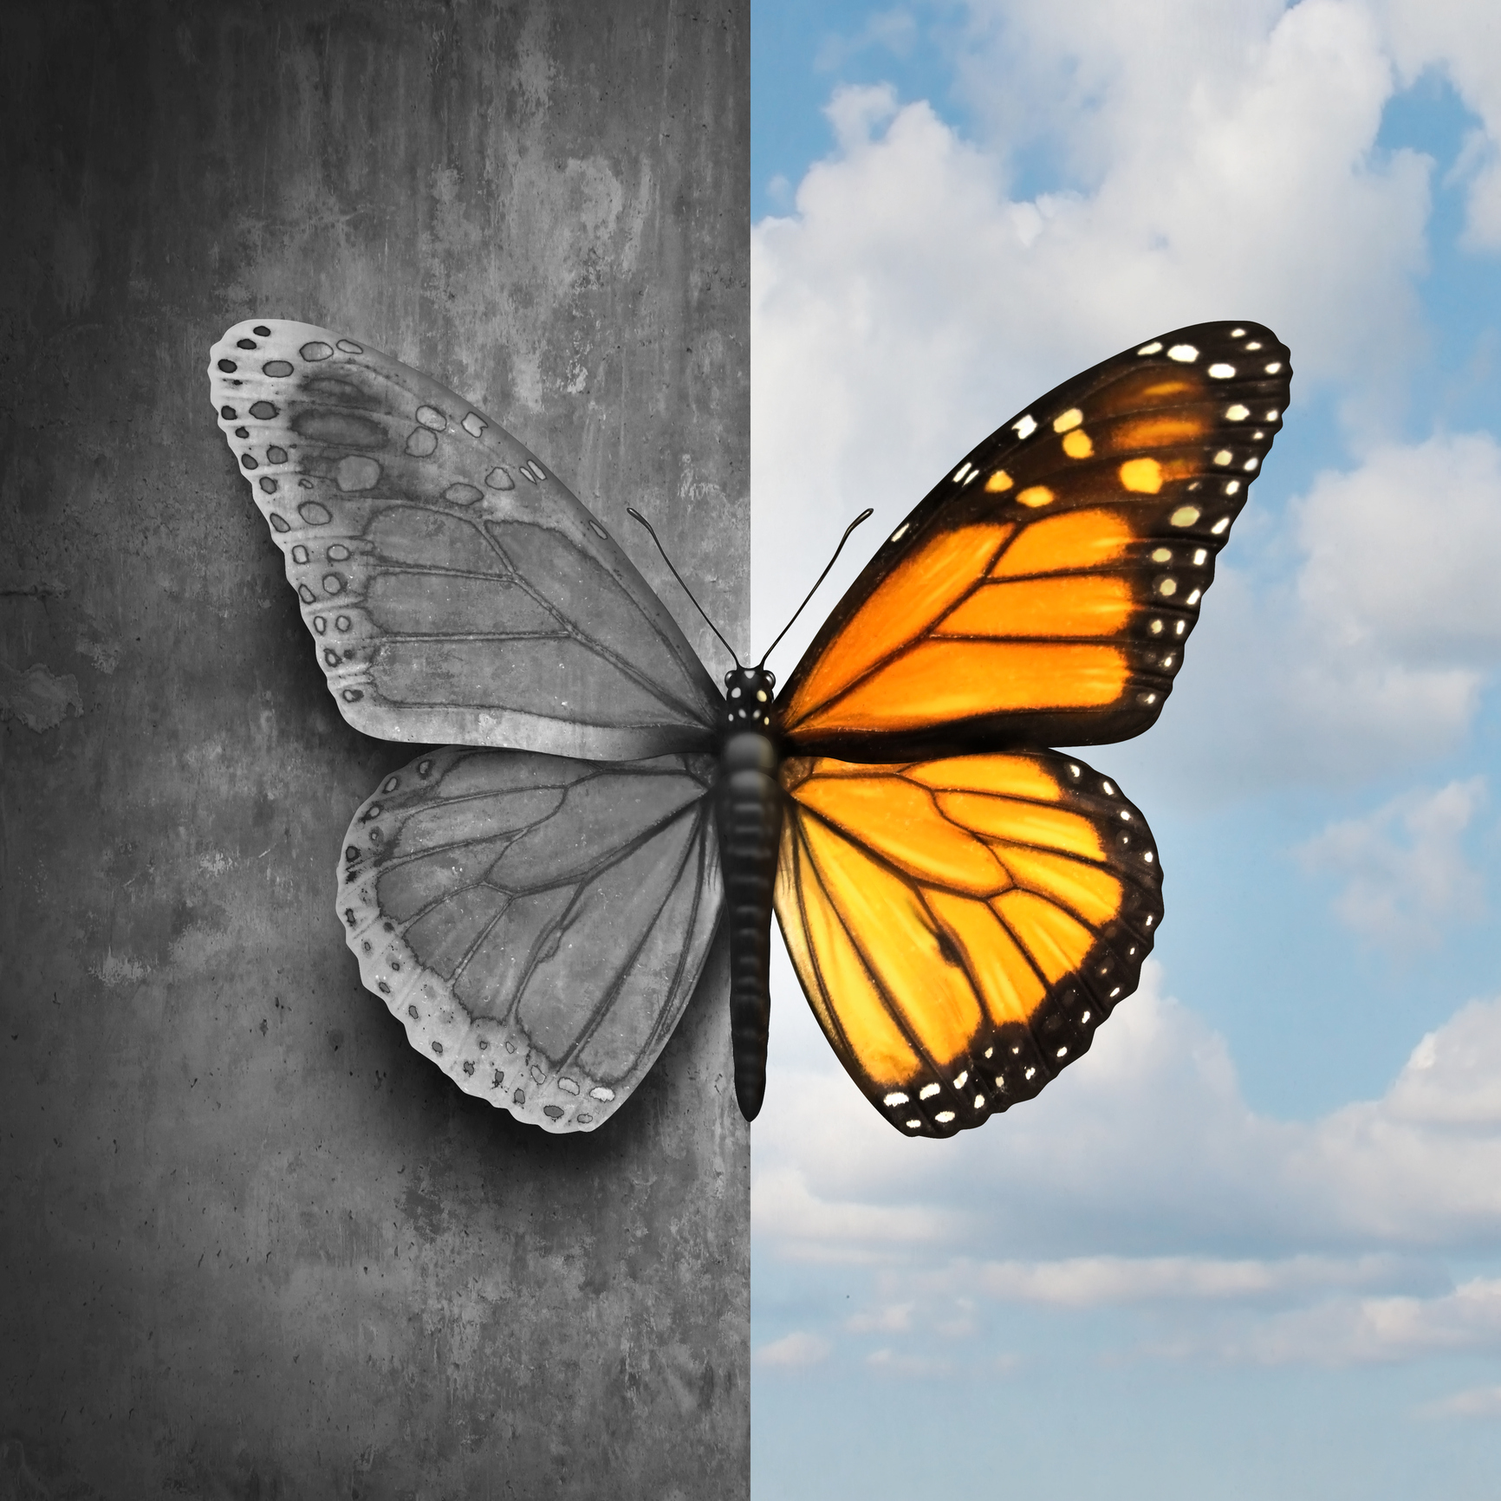  A Reason to Hope  The Means to Cope!  - Schizophrenia Society of New Brunswick  - Tel: (506) 622-1595  - Email: ssnbmiramichi@gmail.com

Causes of Bipolar  The exact cause of bipolar disorder is unknown, but several factors may be involved, such as:  - Biological differences. People with bipolar disorder appear to have physical changes in their brains. The significance of these changes is still uncertain but may eventually help pinpoint causes.  - Genetics. Bipolar disorder is more common in people who have a first-degree relative, such as a sibling or parent, with the condition. Researchers are trying to find genes that may be involved in causing bipolar disorder.  Some Common Symptoms of Bipolar  Mood Swings  Euphoria  Rapid Speech  Racing Thoughts  Irritation  Increased Physical Activity  Careless Use of Drugs/Alcohol  Decreased Need for Sleep  Missed Work  Fatigue  Chronic Pain with No Known Cause  Sadness/Hopelessness  Suicidal Thoughts | Types of bipolar  - Bipolar I disorder involves periods of severe mood episodes from mania to depression.  - Bipolar II disorder is a milder form of mood elevation, involving milder episodes of hypomania that alternate with periods of severe depression.  - Cyclothymic disorder describes brief periods of hypomanic symptoms alternating with brief periods of depressive symptoms that are not as extensive or as long-lasting as seen in full hypomanic episodes or full depressive episodes.  - "Mixed features" refers to the occurrence of simultaneous symptoms of opposite mood polarities during manic, hypomanic or depressive episodes. It's marked by high energy, sleeplessness, and racing thoughts. At the same time, the person may feel hopeless, despairing, irritable, and suicidal. | Did you know?  Fact #1: According to the National Institute of Mental Health, early-onset Bipolar Disorder affects potentially up to one million teenagers from the ages of 14 to 18.  Fact #2: There is no known cure for early-onset Bipolar Disorder which can begin to show symptoms in children as young as five.  Fact #3: There is currently no empirical test, no biomarker test, no blood test, no MRI and no genetic test yet developed to scientifically show that someone has Bipolar Disorder.  Fact #4: Bipolar Disorder in children and adolescents may be different from the adult form of this illness. Children and adolescents are more likely to be irritable and prone to destructive outbursts than to be elated or euphoric.  Fact #5: Bipolar Disorder used to be called manic depression.  Fact #6: It is not uncommon for children and adolescents with Bipolar Disorder to self-medicate and develop issues with chemical and substance abuse.

